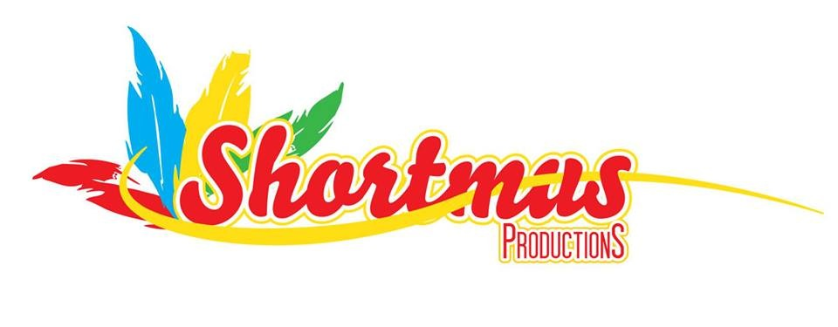
SHORTMUS PRODUCTIONS
2112 Mount Holly Street
Baltimore, MD 21216

To Whom It May Concern.
Our organization (Shortmus Productions) is currently entering into its 18th year as a participant in the annual Baltimore DC One Caribbean Carnival. In keeping with our portfolio of the promotion of St Vincent and Grenadines on the International level, we value this opportunity to showcase our nation's culture on such a Grand Stage.
Baltimore DC One Caribbean Carnival will be held this year on July 15th, 2017. This allows us to give our country much needed visible representation. It allows us to showcase our heritage and our many cultural depictions. It also allows us the opportunity to join with the Caribbean Community. This event with all of its beauty and splendor attracts more than one hundred thousand persons. It also attracts most of the mainstream media that increases the visibility of the event.
We would very much like to continue our participation in this event. Therefore, we are kindly requesting your sponsorship to ensure our successful participation in this event. We have different levels of sponsorship that we are hoping you will be interested in.
1) You can sponsor a kid to be in the parade for a $150.00 value. We are proud to announce that through the generosity of companies like yours, we are able to sponsor kids into the parade and would like to increase the numbers as we grow.
2) We can display Banners on the Float/Truck. Banner Packages ranges from $450.00 to $3,500.00. You can also contact me at shortmus@msn.com. www.shortmusproductions.com.
Thank You for your kind consideration.
Sincerely!
Kenley John/202-549-4142
Bandleader.
SHORTMUS PRODUCTIONS.

